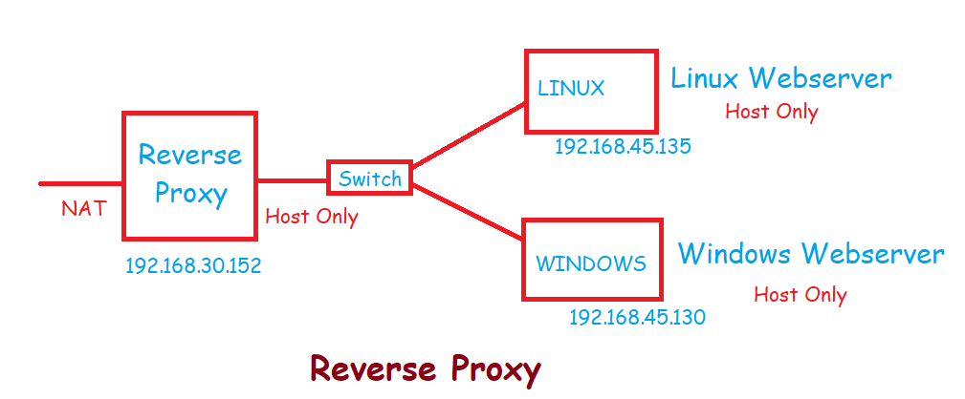

LINUX Webserver – 10.10.10.137

WIN Webserver – 10.10.10.133

On Linux machine :

After install the httpd service then change the adapter from nat to host

# yum install httpd -y

# cd /var/www/html

# ls

# vim index.html

This is linux web server !!!!!!!

:wq for save & exit

# systemctl start httpd

# systemctl enable httpd

#

On Windows machine:

Go to the This pc then go to the C drive -> inetpub -> wwwroot -> create a folder and create one text file with index.html

This is windows website hosted file !!!!!!!!

Then go to the IIS manager click on sites and then add website then give the name for website and select the path and give the port no for that file.

Then start the website

On CMD  
Ipconfig —--- to view ip of the windows machine

Then go to the browser and put this ip on url the /folder name

I.e 192.168.45.130/web1

Or

192.168.45.130:8000

On the Linux machine

# curl http://10.10.10.137

# curl http://10.10.10.133

# systemctl start firewalld

# systemctl enable firewalld

# firewall-cmd --add-service=http

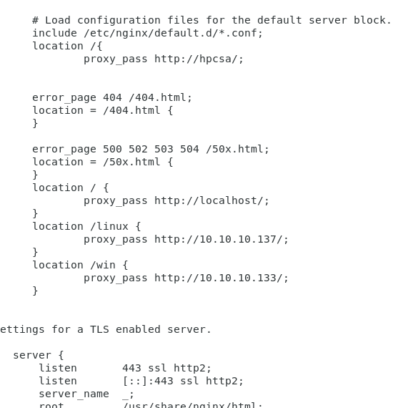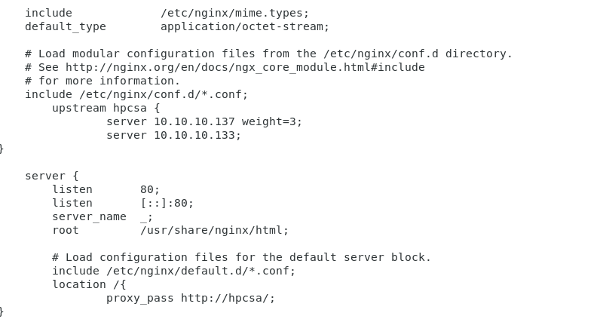

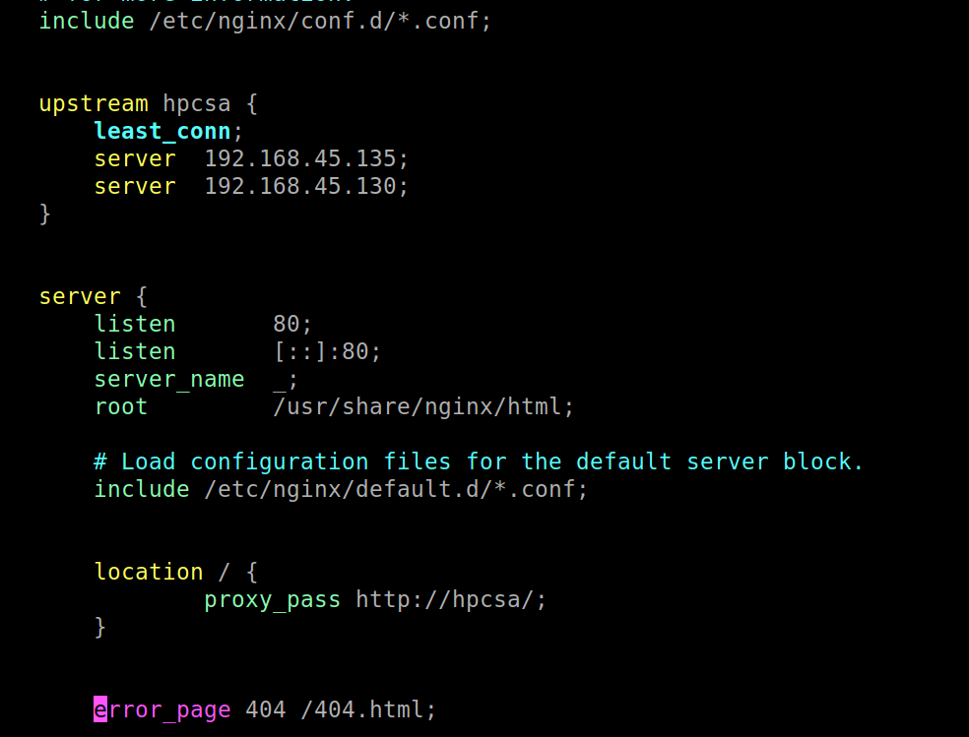

**************************** nginx.conf file ***********************************************************

# Load dynamic modules. See /usr/share/doc/nginx/README.dynamic.

include /usr/share/nginx/modules/*.conf;

events {

worker_connections 1024;

}

http {

log_format main '$remote_addr - $remote_user [$time_local] "$request" '

'$status $body_bytes_sent "$http_referer" '

'"$http_user_agent" "$http_x_forwarded_for"';

access_log /var/log/nginx/access.log main;

sendfile on;

tcp_nopush on;

tcp_nodelay on;

keepalive_timeout 65;

types_hash_max_size 4096;

include /etc/nginx/mime.types;

default_type application/octet-stream;

# Load modular configuration files from the /etc/nginx/conf.d directory.

# See http://nginx.org/en/docs/ngx_core_module.html#include

# for more information.

include /etc/nginx/conf.d/*.conf;

upstream app1 {

server 10.10.10.133:8010;

server 10.10.10.133:8020;

}

upstream app2 {

server 10.10.10.133:8030;

server 10.10.10.133:8040;

}

#upstream hpcsa {

# ip_hash;

# server 192.168.45.135;

# server 192.168.45.130;

server {

listen 80;

listen [::]:80;

server_name _;

root /usr/share/nginx/html;

# Load configuration files for the default server block.

include /etc/nginx/default.d/*.conf;

location / {

proxy_pass http://localhost/;

}

location /app1 {

proxy_pass http://app1/;

}

location /app2 {

proxy_pass http://app2/;

}

#

# location /hpcsa {

# proxy_pass http://10.10.10.133:9002/;

# }

#

# location /ditiss {

# proxy_pass http://10.10.10.133:9500/;

# }

********************************************************************************************************

alert icmp any any -> 192.168.30.144 any (msg:"large ping packets detected";dsize:>512;sid:1000003;)

alert tcp any any -> 192.168.30.144 any (msg:"Possible syn NMAP Scan";flow:stateless;flags:F;sid:1000005;)

alert tcp any any -> 192.168.30.144 any (msg:"Possible fin NMAP scan !!"flow:stateless;flags:S;sid:100001;)

alert tcp 192.168.30.140 any -> 192.168.30.144 8200 (msg:"Hackers website accessed";content:"hack";nocase;sid:1000002;rev:1;)

alert tcp any any -> 192.168.30.144 (msg:"SSH login detected ";sid:1000006;)

alert tcp any any -> 192.168.30.140 any (msg:"restricted website is accessed:;sid:1000008;)

block tcp any any -> 192.168.30.140 any (msg:"restricted website is block";sid:1000009;)

#alert tcp !192.168.30.188 any -> 192.168.30.144 22 (msg:"Invalid SSH access";sid:1000004;)